# **Generic Intro and Case Study Questions**

Lean Scale’s MTP “Massive Transformative Purpose” is :

“Disrupt comfort zones to unleash exponential thinking."

We believe if you want to achieve great things, you need to move out of your comfort zone and take the risk in all areas. **The risk of not taking the risk can not be tolerated in an era where we live.** And you can not become who you want to be by staying happy but vulnerable in your comfort zone.

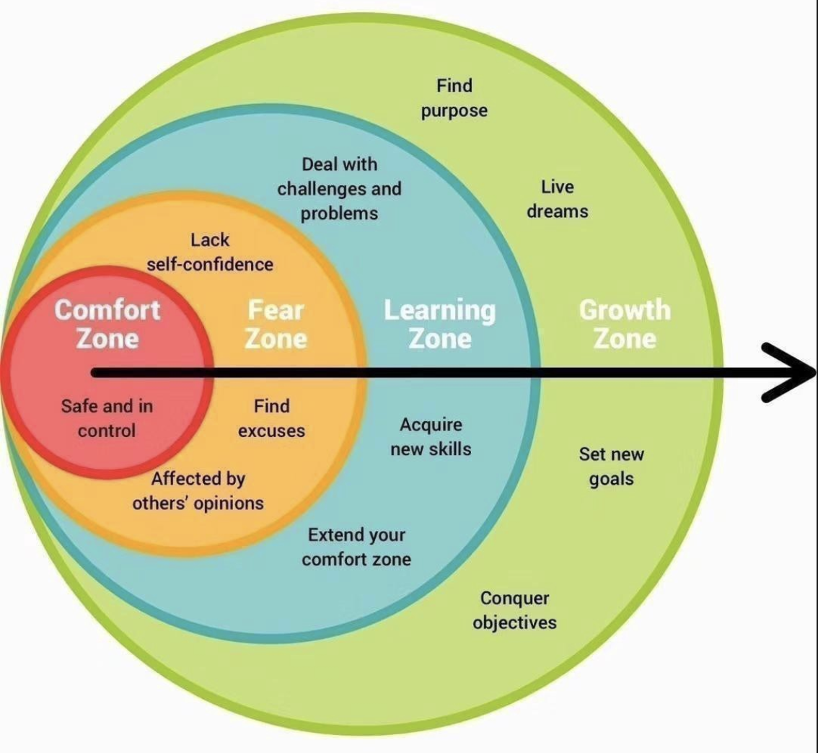

We are based in Dubai and would like to build **Amoeba kind of organization** where we will have small, distributed and autonomous teams to disrupt our client base’s business and as well ourselves as well. Our client base is mainly in the MENA region (not necessarily all of them are from MENA) as a starting point where we believe there is a huge disruption opportunity and we are building distributed teams based in Turkey, Ukraine & Sri Lanka to support our engagements. (as a starting point)

We are digital venture/products

**co-builder,**

**co-enabler** &

**co-scaler.**

We are looking for people who would like to be doing this not only for clients but also for ourselves, by disrupting their/our comfort zones to unleash the exponential thinking. We leverage and put **Lean Methodology** and **EXO (Exponential Organizations)** principles at the center of what we are doing for our own organization and for our clients. Hence we are looking for people with a similar mindset: People who would like to "Disrupt their and our clients’ comfort zones"

We believe the following five domains can build any business from scratch in our era (not in any order):

1. **Entrepreneurship**
2. **Technology**
3. **Product**
4. **Data & Insight**
5. **Marteching** are compelling capabilities to co-build and co-scale any businesses.

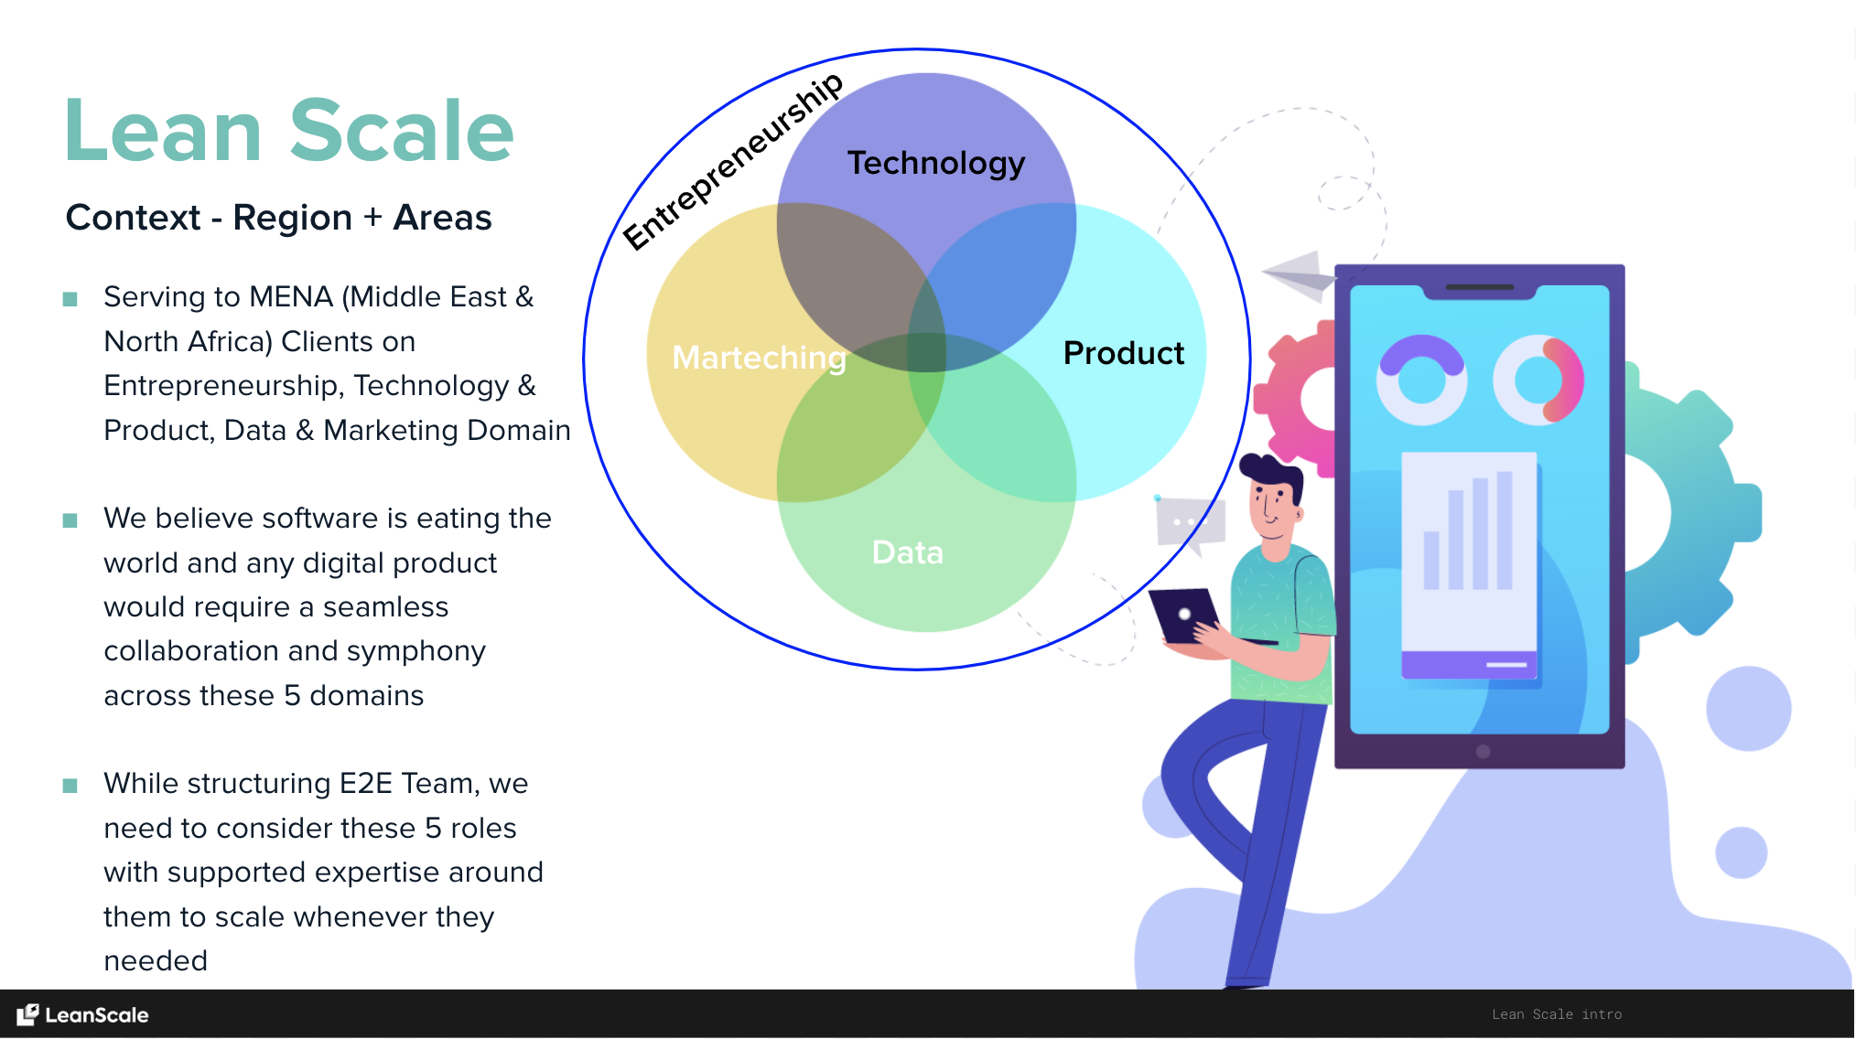

Our values are **Exponential (Abundance) mindset, Radical Transparency**, **Meaningful Relationships**, **Willing to disrupt comfort zones**, **Beginner’s Mind**, **Entrepreneurial-mind**, **Vulnerability-based Trust**, **Commitment**, **Accountability**, and **Result-Orientation.**

As Lean Scale, we look for 3 types of engagements with our candidates:

1. **To be hired in the Lean Scale”Lean Scale Model”**: This is where we evaluate the DNA match based on our Lean Scale principles through Generic Case Study that you are going to review. In this context, we are expecting you to get involved in our internal dynamics and our internal engagements to follow our MTP. Here, our expectation is to be part of Lean Scale journey for internal and external projects and eventually create your own journey thru Lean Scale. We are expecting Entrepreneurial, M-Shaped minded people who are willing to disrupt their comfort zone willing to take high risk & long term gain
2. **Team Building (Client Hiring):** Either for a new or existing digital journey, we help our clients to build their digital capability by setting the business model, EXO Model, digital strategy, defining the operating model, idea-to-delivery framework, build a Minimum Viable and Lovable Product following EXO Principles. And eventually recruit, hire the remote-culture team and incubate our clients. In this model, you will be working with us for a while during our incubation period but eventually you will be in the core team we are building for our client after we leave
3. **Freelance/Partner model:** Based on mutual agreements for pre-agreed time and project engagements. In this context, we expect your expertise is prominent and you are willing to have pre-agreed, pre-structured engagement, not necessarily following the Lean Scale principles but still following basic work ethics principles. (reliability, accountability. Trust on the tasks you are assigned). Our expectation is to do your job with your high technical expertise based on projects and the timeline we have agreed before.

In these 3 models, our expectations on the technical area where you are being positioned are exactly the same (e.g. your expertise and level of being a product manager, or lead front end developer etc) and they are not superior to each other. They simply approach life from different angles. We respect everyone’s angle and hence we would like to make it clear from the very beginning and decide on which type of engagements we are gonna work together. The only expectation we have from you is being honest and transparent. The case study below hopefully will help both of us if we are a good match for the “Lean Scale model” or we can have a better way of engaging each other in the other 2 domains. As stated above, our expectations for your technical skill sets are independent of the type of engagements and we always look for high potential. By the way, we don't have any problem for candidates to start the testing period with us and see how these 3 models work for a limited period of time and decide later. Although we have very detailed and specific case studies on Generic and Technical level, we know that nothing will make it more clear to spend some time working on the same goal and project together.

Below is the high-level Executive Summary of what the “Lean Scale” model is looking for:

We are looking for M shaped, Entrepreneurial-minded people who would be motivated to help build and live the Lean Scale's DNA, culture, and work ethic from scratch with the "Bootstrapping Approach.". We would like them to learn how to disrupt existing industries and businesses, learn the importance and journey for how to become a team. Hopefully, and eventually, we want them to build their journey through the Lean Scale ecosystem and support to grow this ecosystem exponentially.

The team you will be part of will be belonging to Lean Scale and its partner members in different cities where the team;

* it will evolve and spin-off as separate team & countries whenever it reaches a specific size (25-30 people per country)
* People have an Entrepreneurial mindset; they are M-Shaped people and Progress focus: "How can I make myself useless so that I can learn new things"?
* People believe the new era of organization & structure is needed
* People think Abundance-based "exponential thinking" will be eating scarcity-based "linear thinking" at breakfast
* People strive for Radical transparency, radical open-mindedness, the art of thoughtful disagreement and idea meritocracy
* People believe, Progress = Failure + Reflection: They know If they're not worried, they need to worry. And if they're worried, they don't need to worry. Healthy paranoia is good for progress
* People believe subject matter of expertise is essential but overvalued and they strive for an ecosystem with "unlearning" capabilities
* People who are willing to learn new things as well as being hands-on wherever it is needed. We don’t want to hear “I was doing this 10 years ago” and instead we would like to hear “how can I automate it so I don’t need to do it again”
* People where titles are not important but the impact on his/her career, on the company on society is more important
* People who are motivated not only working on helping clients but also motivated to be part of Venture Builder Service that Lean Scale would like to handle and eventually willing to be part of the new companies Lean Scale is willing to spin-off each year. Unlike the other companies, we don’t want you to dream working within Lean Scale for long years but learn how to disrupt our clients’ industries and eventually co-build your own dreams together with your colleagues within the Lean Scale

To do so:

Tell us which kind of mindset you will bring to the table;

First, we will provide you generic questions (as part of this document/form and this document/form will be referred/embedded to all other case studies as Generic Questions) as stated below for all candidates. And if we believe your answers for "Generic Questions" are significant signals for our collaboration and future, they will be followed by technical "Role Specific Questions" related to your role: (which will be part of a separate document)

We believe the questions below will give us a clear understanding of your way of working. Some of them are we believe mandatory and highlighted as **(M),** and the rest is optional **(O).** Please have a look and challenge us. You can answer all or some of them. It's up to you how to present. You can write a text, you can build beautiful slides, you can record videos, or you can mix em all.

Or you can avoid all/some of them and add your questions and answer them by uploading your version as word, presentation, or video format.

The below is just guidance, and in exchange, we are looking for "your guidance" to convince us that you are our journey-mate/comrade:) One key consideration for this exercise is clarity. For technical or non-technical questions, please explain clearly your point of view (answer), highlight the logic, reasoning behind, and highlight references, if any. Whenever you are in doubt about a particular response, we are happy to hear your thoughts on alternatives and your "testing" approach for different options. Remember, this is the place where we would like to see how your brain and heart work together.

### 1. Tell us about yourself. - Personal

a. **(M)**Please look at the drawing below. It's a new way of presenting Ikigai. If you don't know the concept, please read: https://en.wikipedia.org/wiki/Ikigai

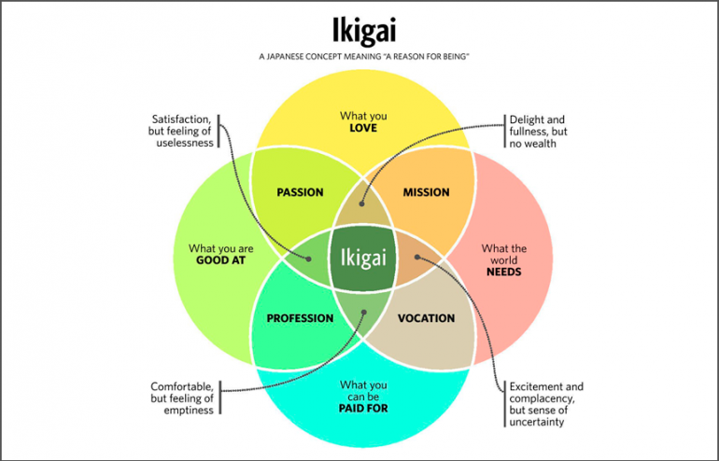

The graph above is a new way of visual representation of Ikigai. Please have a look and let us know how you define the following concepts with one sentence for your life (we are expecting you to determine your specific one(s)):

● Ikigai:

The purposeful combination of my talents, passions, and values that brings me joy, fulfillment, and a sense of meaning in life.

● Passion:

The driving force that ignites my soul, fuels my creativity, and compels me to pursue my deepest interests and desires

● Mission:

The overarching goal or purpose that guides my actions and motivates me to make a positive impact in the world

● Profession:

The field or occupation in which I apply my skills, knowledge, and expertise to earn a living and contribute to society.

● Vocation:

The innate calling or sense of duty that aligns with my values and enables me to serve others while finding personal fulfillment in the process.

b. **(M)**What would be the invention that you would love to invent in human history? Tell us the reasoning? Why would you like to do that? And why would it be "you" rather than someone else, to invent that? In which context would it come to your mind? Build a coherent story behind it, considering your Ikigai. (A great structure to explain this is: Probably if I would invent anything in history, I’d like to and would be able to invent ….. And it would come into my mind due to the following reasons: …… )

Probably if I were to invent anything in history, I would like to invent a service to help people reach their beloved family and friends and easily communicate with them. I would also add a tangible element to the service to make the communication visual and sensory. The reason behind my thinking is as follows:

- Due to the presence of many friends and family members living abroad.

- Creating opportunities for siblings and spouses to connect so that every person living abroad can communicate and feel the presence of their loved ones.

c. **(M)**How would you define yourself with one sentence? Tell us three positive adjectives and three negative adjectives your friends will tell about you

if I were to define myself in one sentence, it would be: "I am a dedicated and skilled professional committed to delivering high-quality iOS applications."

Three positive adjectives my friends might use to describe me are:

* Diligent: I am known for my hard work, attention to detail, and persistence in tackling complex challenges.
* Knowledgeable: I possess a deep understanding of iOS development and stay up to date with the latest trends and technologies in the field.
* Reliable: My friends can count on me to deliver results, meet deadlines, and provide valuable support and guidance when needed.

Three negative adjectives that my friends might mention are:

* Perfectionist: Sometimes, I can be overly meticulous, striving for perfection, which can lead to spending extra time on tasks.
* Reserved: I tend to be introverted and may not always be the most outgoing or assertive person in social situations.
* Impatient: On occasion, I may become impatient when faced with delays or inefficiencies, although I actively work on managing this aspect of my temperament.

d. **(O)**Who are three people you follow as thought leaders for your work life?

1. Paul Hudson
2. John Sundell
3. Antoine van der Lee

e. **(O)**How do you feed yourself in technology and product domain to follow the new things? Which resources do you use (pick top 5), and when you find something interesting, where do you keep and store them?

f. **(M)**We believe there are seven things that you need to prioritize for the next 2-3 years of your life constantly. Health is the first one, so we keep this out of this equation:) Please sort the following six things in order of importance for yourself and please highlight the reasoning for each line

i. **Compensation** (Total amount you get out of the job including salary, bonuses, allowances or any future benefits and importance of this in terms of ranking in your next 2-3 years journey))

ii. **Family:** (Your family: either you are married or your father, mother or extended family and importance of this in terms of ranking in your next 2-3 years journey))

iii. **Work & Life Balance:** (Not necessarily linked to the family but to have more time for yourself to do different things or enjoy, travel, etc. and importance of this in terms of ranking in your next 2-3 years journey))

iv. **Whom do you work for?** (the person you want to be working for or the person you don't want to be working for:) and of this in terms of ranking in your next 2-3 years journey))

v. **Whom do you work with?** (a type of people that you would like to work with and importance of this in terms of ranking in your next 2-3 years journey)

vi. **Doing new & exciting things?** (a type of work and skills you grow and willing to do the things you find exciting and new: and the importance of this in terms of ranking in your next 2-3 years journey)

(For Question f, we are expecting you to rank these six things, explain what you expect at a high level in each of them and give clarity to us your next 2-3 years goal of your life in this framework. On Compensation, we are not looking for strict numbers but high-level aspirations you have)

Ranking the six factors in terms of importance for the next 2-3 years of my life, considering my role as an iOS senior developer in Egypt, I would prioritize them as follows:

* Doing new & exciting things: Innovation and growth are crucial for my professional development. It is important to me to continuously challenge myself, learn new skills, and work on exciting projects. By embracing new technologies, exploring creative solutions, and staying updated with industry trends, I can enhance my expertise and keep my work engaging and fulfilling.
* Work & Life Balance: Achieving a healthy work-life balance is essential for my overall well-being and long-term sustainability. I value having time for personal interests, hobbies, and spending quality time with family and loved ones. Balancing work commitments with personal life helps maintain motivation, reduces burnout, and promotes a sense of fulfillment and happiness.
* Compensation: While compensation is important, it is not my top priority. Fair compensation is necessary to meet financial responsibilities and maintain a comfortable lifestyle. However, my focus lies more on personal growth, job satisfaction, and making a meaningful impact through my work rather than solely on monetary rewards.
* Whom do you work with: Collaborating with talented and supportive colleagues plays a significant role in fostering a positive work environment. Working with like-minded individuals who share a common vision and values can lead to a more enjoyable and productive experience. Building strong professional relationships and being part of a cohesive team are important factors for my success and personal growth.
* Whom do you work for: The leadership and management style of the organization I work for can greatly influence my job satisfaction and growth opportunities. A supportive and inspiring leader who values employee development, provides guidance, and creates a positive work culture contributes to a fulfilling professional journey.
* Family: While family is of utmost importance in my personal life, in the context of my professional journey, it ranks lower compared to the other factors. While I aim to maintain a healthy work-life balance and spend quality time with my family, my primary focus within this framework is on career-related aspects.
* In the next 2-3 years, my goal is to continue growing as an iOS senior developer by taking on new and exciting projects that allow me to innovate and expand my skill set. I strive for a work-life balance that enables me to pursue personal interests and spend quality time with my loved ones. While fair compensation is important, my focus lies more on personal and professional growth, collaborating with talented colleagues, and working for an organization that values employee development. By prioritizing these aspects, I aim to achieve satisfaction, continuous learning, and make a meaningful impact through my work.

g. **(M)**Related to this, we would like you to rank all the options within “CHAMPFROGS model for intrinsic motivation” that are listed below. Addition to that please put one sentence as a brief explanation for the only top 3.

### **CHAMPFROGS**

**C**uriosity: I have plenty of things to investigate and to think about.

**H**onor: I feel proud that my personal values are reflected in how I work.

**A**cceptance: The people around me approve of what I do and who I am.

**M**astery: My work challenges my competence but it is still within my abilities.

**P**ower: There’s enough room for me to influence what happens around me.

**F**reedom: I am independent of others with my work and my responsibilities.

**R**elatedness: I have good social contacts with the people in my work.

**O**rder: There are enough rules and policies for a stable environment.

**G**oal: My purpose in life is reflected in the work that I do.

**S**tatus: My position is good, and recognized by the people who work with me.

Ranking the options within the CHAMPFROGS model for intrinsic motivation, listed below, I would prioritize them as follows:

1. Mastery: My work challenges my competence but is still within my abilities. (Brief Explanation: The opportunity to continuously learn and grow in my work is essential for me to stay motivated and engaged.)

2. Curiosity: I have plenty of things to investigate and think about. (Brief Explanation: A sense of curiosity and the opportunity to explore new ideas and concepts keeps me motivated and intellectually stimulated.)

3. Relatedness: I have good social contacts with the people in my work. (Brief Explanation: Building strong relationships and having a sense of connection with colleagues creates a positive work environment and enhances my motivation and job satisfaction.)

4. Freedom: I am independent of others with my work and responsibilities.

5. Power: There's enough room for me to influence what happens around me.

6. Honor: I feel proud that my personal values are reflected in how I work.

7. Acceptance: The people around me approve of what I do and who I am.

8. Order: There are enough rules and policies for a stable environment.

9. Goal: My purpose in life is reflected in the work that I do.

10. Status: My position is good and recognized by the people who work with me.

### 2. (**M**)Have you applied to the Myers-Briggs Framework before? Although we do not think this kind of test gives everything about a person, we believe it provides some information. As we will not have time to perform the test, can you let us know your personality type if you have done it before?

a. If not, can you look at the picture below and let us know which one makes more sense to you and why? (Text is ok)

ESTJ is more sese to me .

ESTJ stands for Extraverted, Sensing, Thinking, and Judging. Cause I see that my personality is practical, organized, efficient, and enjoy taking charge of situations.

b. Can you also do your honest guest on, “How do you think people perceive you?” (Text is ok)

They may see me as someone who values structure and order, and who approaches tasks and responsibilities in a focused and systematic manner.

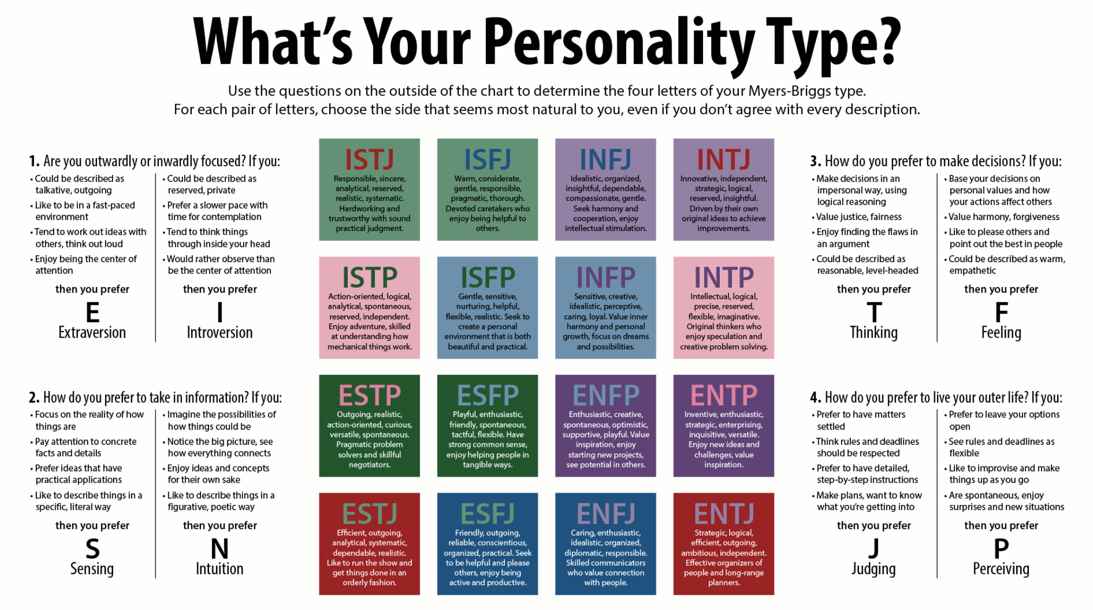

● Based on the personality type you have seen above: (1 slide)

○ What kind of people do you like working with (please highlight with the personality type and reasoning)?

I prefer working with individuals who share similar traits or complement my working style. Some potential personality types i might enjoy working with could be:

1. ISTJ (Introverted, Sensing, Thinking, Judging): ISTJs are typically detail-oriented, reliable, and value structure. They may appreciate your organized and efficient approach to work, and together you can create a structured and productive work environment.
2. ENTJ (Extraverted, Intuitive, Thinking, Judging): ENTJs are often confident, strategic thinkers, and natural leaders. They may align with your goal-oriented and decisive nature, creating a dynamic partnership that drives results and fosters growth.
3. ESTP (Extraverted, Sensing, Thinking, Perceiving): ESTPs are often action-oriented, adaptable, and enjoy problem-solving. Their spontaneity and willingness to take risks may complement your practicality, leading to a collaborative and dynamic working relationship.

○ What kind of people did you have difficulty working in the past? (please highlight with the personality type and reasoning)?

* + - INFP (Introverted, Intuitive, Feeling, Perceiving): INFPs tend to be idealistic, creative, and value personal connections. Their preference for harmony and flexible approaches may contrast with your more practical and structured mindset, potentially leading to communication differences or conflicts in work styles.
    - ENFP (Extraverted, Intuitive, Feeling, Perceiving): ENFPs are often enthusiastic, imaginative, and value exploration. Their preference for generating ideas and seeking possibilities may differ from your focus on efficiency and productivity, potentially leading to challenges in aligning goals or decision-making processes.
    - ISFP (Introverted, Sensing, Feeling, Perceiving): ISFPs are typically sensitive, artistic, and value personal expression. Their preference for individuality and flexible work environments may differ from your preference for structure and organization, potentially leading to differences in approaches and potential friction.

### 3. (M)Please watch the following two videos

* Exponential Organizations:<https://www.youtube.com/watch?v=FNQSM4ipZog>
* Ray Dalio:<https://www.youtube.com/watch?v=HXbsVbFAczg>

a. Please list the top 3 things you like, and you can apply to your work life and top 3 things you didn't like, and you want to avoid applying to your work life in each of these videos separately (3 likes and three dislikes per each video) (Text is ok)

b. Please read:<https://blog.growthinstitute.com/exo/massive-transformative-purpose> and watch the video inside that link.

Please think and let us know two things:

* your MTP
* and also, what would be the ideal MTP that you would like to work in a company for?

### 4. (O) Please answer the following famous Peter Thiel’s interview question for us: (Text is ok)

"What important truth do very few people agree with you on?":

meaning where would you bet against the consensus of the social norms? (hint, 200 years ago, slavery was a norm for some countries, but there were still people who believe it was wrong, tell us the similar thing you think it is wrong right now, but most of the people still follow and agree.)

5. **(O)**Tell us what we should do differently during the interview process? (apart from long case studies) (Text is ok)

6. **(O)**Please tell us three things you believe you are best at and you can coach us and explain how you can coach us? (1 slide)

a. Addition to above: Now tell us including or excluding these three things: Where should we expect you to make an impact?

b. What was the proudest moment in your career within the last two years? Who would be the main person you would like to thank for that moment?

c. Tell us when was the last time praised/ someone in the work environment? Tell us the motives and impacts you have seen.

### 7. **(M)**Please think about your current expertise, what you are good at, what is your background, and eventually your comfort zone. Now tell us how you would disrupt that industry/ area / domain finally make yourself useless? (Text is ok)

We always want our team to have a Beginner's Mind and Unlearning capabilities. We will be working for our clients and for ourselves on the projects that we need to learn faster, adapt faster, and understand the "repeated patterns" so that we can understand how we can be 10 X efficient. To do so, we are looking for individuals, who will keep three things always in their mind and after learning a new thing, focus on understanding the patterns so that he/she can automate or delegate to make him/herself useless.

Here we would like to understand how you can make yourself useless in the area that you have your comfort zone and learn new things? Give us some concrete examples of the areas that you think you can identify patterns and then find a way to complete them more efficiently. For instance, If we ask you to become an expert on our framework or domain (something that was new for you), what would be your thought process and approach to handover / automate your current line of expertise and move to a new domain?

As an iOS senior developer & team lead, I constantly strive to challenge myself and explore new possibilities within my current expertise. However, I also understand the importance of pushing boundaries and disrupting the industry to foster innovation and growth. Here's how I would approach disrupting the industry and eventually making myself useless:

1. Embrace a Beginner's Mind: I would cultivate a mindset of curiosity and openness, always willing to learn and unlearn. By adopting a beginner's mind, I can avoid complacency and continuously seek new knowledge and skills.
2. Identify Patterns: I would actively analyze the industry, area, or domain I'm working in to identify recurring patterns and trends. This includes examining common challenges, user behaviors, and emerging technologies. Understanding these patterns allows me to anticipate future developments and adapt accordingly.
3. Automate and Delegate: Once I grasp the patterns and gain expertise in a particular area, I would focus on automating repetitive tasks and delegating responsibilities to streamline workflows. By automating routine processes, I free up time to explore new domains and enhance efficiency.
4. Collaborate and Mentor: To render myself useless in my comfort zone, I would actively collaborate with colleagues and share knowledge. I would mentor team members, enabling them to acquire expertise in my current domain and gradually take over responsibilities. This transfer of knowledge empowers others and allows me to venture into new areas.

For example, if asked to become an expert in a new framework or domain, my thought process would involve:

* Understanding the requirements: I would thoroughly analyze the framework or domain's objectives, challenges, and potential benefits. This helps me align my skills and expertise accordingly.
* Identifying transferable skills: I would evaluate the similarities and overlaps between my current expertise and the new framework or domain. This allows me to leverage my existing knowledge and quickly grasp the fundamentals.
* Leveraging resources: I would actively seek resources such as documentation, online courses, and expert advice to accelerate my learning process. Utilizing these resources efficiently enables me to ramp up my understanding swiftly.
* Hands-on experience: I would engage in practical projects or assignments within the new framework or domain to gain firsthand experience. This practical exposure aids in identifying patterns and developing effective strategies.
* Mentorship and transition: Concurrently, I would mentor team members in my previous area of expertise, gradually delegating tasks and knowledge transfer. This smooth transition ensures continuity and empowers others to excel.

By following this approach, I can disrupt my comfort zone, acquire proficiency in new areas, and empower my team members to take on leadership roles, ultimately rendering myself "useless" in the initial domain.

Top of Form

Bottom of Form

### 8. **(M)**What would be the purpose + culture + values you would like to be part of? How would you be motivated? (Text is ok) Which are the companies (give us a minimum of two examples) you like their purpose + culture + values and why?

As an iOS senior developer, I seek to be part of a purpose-driven organization with a positive culture and aligned values. Here's the purpose, culture, and values I would like to be part of, along with how I would be motivated:

Purpose:

I would like to be part of a company that has a clear and meaningful purpose. It could be focused on creating innovative solutions, making a positive impact on society, or improving the lives of individuals through technology. A strong sense of purpose motivates me to contribute my skills and efforts towards a greater cause.

Culture:

I value a collaborative and inclusive culture that fosters teamwork, creativity, and growth. A culture that encourages open communication, knowledge sharing, and continuous learning is essential for me. I thrive in an environment where individuals support and inspire each other, and where diverse perspectives are respected and valued.

Values:

I appreciate organizations that uphold integrity, transparency, and ethical practices. I value companies that prioritize quality and excellence in their work, while also maintaining a healthy work-life balance for their employees. Respect for individuals, empowerment, and accountability are also important values that I look for in a company.

Motivation:

I am motivated by challenging projects that allow me to apply my skills, learn new technologies, and solve complex problems. Recognition and appreciation for my contributions, as well as opportunities for growth and career advancement, are also key motivators for me. A supportive and positive work environment where I can collaborate with talented individuals and make a meaningful impact further fuels my motivation.

Companies I admire for their purpose, culture, and values:

1. Apple: Apple's purpose of creating innovative products that enhance people's lives resonates with me. Their culture of excellence, attention to detail, and emphasis on user experience align with my values as an iOS developer. Apple's commitment to privacy, accessibility, and sustainability also demonstrates their ethical practices, which I greatly appreciate.

2. Google: Google's purpose of organizing the world's information and making it universally accessible and useful is inspiring. I admire their culture of innovation, continuous learning, and fostering a creative work environment. Google's emphasis on diversity, inclusion, and employee well-being reflects their commitment to creating a positive and supportive workplace.

Both Apple and Google are renowned for their technological advancements, user-centric approach, and commitment to quality. These companies prioritize employee growth, offer opportunities to work on cutting-edge projects, and promote a culture of collaboration and innovation. These factors make them appealing examples of organizations that align with my desired purpose, culture, and values.

### 9. **(M)** “When, if ever, is lying permissible?” Please answer it from your end (you may need to lie to someone) or from a much broader perspective (where and in which context you forgive lies). And let’s make it more interesting: What was the last time you lied and what was the justification behind it? (Text is ok)

### 10. **(M)** We believe in the Minimum Viable and Lovable Product concept within the limitation and direction of Customer Experience. So, we would like to treat our internal or external stakeholders in the same way: We either get their problem/desire as a request, or we understand without them telling us. We design a solution. We get early insights from them. We collect as many data points, track and analyze the results, and we iterate until we believe the problem is resolved or opportunity is created. We believe this can apply to all phases of our daily routine.

So, when some problem is shared with you and ask to complete and bring an outcome, you may have two choices:

1) Gather as much detail as possible you can, understand the pain points, always be interactive, ask any question you want. By giving early insights, design a solution, document and build it and test with your customer. More interaction but more time consuming for the other party. Less risk to misunderstand but more time consuming

2) Go back and do massive research, don’t disturb that much your clients, ( or us in this case) design, test and build your solution and present it at the end with less interaction because either you may think your customer may not know what he/she wants, either you won’t have time to do so. Less time consuming for your client but less interaction and there is a significant chance to misunderstand each other.

As an iOS senior developer, I would prioritize option 1: gathering as much detail as possible, being interactive, and asking relevant questions when presented with a problem or request. Here's why:

1) Gather as much detail as possible: By thoroughly understanding the pain points and requirements, I can ensure that I have a clear understanding of the problem or desire at hand. This allows me to design a more effective solution tailored to the specific needs of the stakeholders involved.

2) Be interactive and ask questions: Regular and open communication with the stakeholders is crucial for clarifying any uncertainties, validating assumptions, and gaining early insights into their expectations. By engaging in active dialogue, I can ensure that I am on the right track and avoid potential misunderstandings.

3) Provide early insights and involve stakeholders: By sharing my progress and involving stakeholders in the design and development process, I can gather feedback early on. This iterative approach enables me to incorporate their insights, refine the solution, and ensure that it aligns with their expectations. It also fosters a sense of collaboration and ownership among the stakeholders.

While option 2 may seem faster initially, it carries a higher risk of misunderstanding the problem or misaligning with the stakeholders' expectations. Relying solely on research without interactive involvement can lead to assumptions that may not accurately address the actual needs of the stakeholders.

By opting for option 1 and emphasizing active communication, collaboration, and iteration, I can minimize the risk of misunderstandings and deliver a solution that meets the stakeholders' requirements effectively and efficiently.

We would like to understand what your framework would be if we assign a task about something that you haven't done before? Please pick a or b and explain the reasoning.

a) Ask the hell out of all details, get as detailed as possible the requirements, lots of interaction with the other party, and spend and request more time. Understand the design wish and go back and build the solution you believe in by minimizing the risk but increasing the time allocation of the client?

b) Listen to the brief, go back and investigate, trust your judgment and be self-sustaining, expect touchpoint requests from us (less interactive, more independent), and show the progress if it is asked, otherwise present the solution at the end. Less interactive, more independent, but more chance to miss what we want and to take the risk to show something at the end but take the responsibility and accountability of failure?

Please explain to us which direction you generally take and which direction you would like us to give you: a, b, or something in between. Please elaborate (text is ok)

As an iOS senior developer, I generally lean towards a balanced approach, which incorporates elements of both option a) and option b). Here's why:

1. Asking for details and interaction: It is essential to gather as much detail as possible about the requirements when assigned a task related to something I haven't done before. Asking questions and engaging in interactive discussions with the stakeholders help clarify expectations, gain insights, and ensure that I have a comprehensive understanding of the problem at hand. This approach minimizes the risk of misinterpretation and ensures that the solution aligns with the desired outcome.
2. Independent investigation and self-sustaining: After receiving the initial brief and gathering the necessary details, I believe in taking ownership of the task and conducting independent investigations. Trusting my judgment and utilizing my expertise, I can explore potential solutions, evaluate different approaches, and make informed decisions. Being self-sustaining allows me to efficiently utilize my skills and knowledge while maintaining a sense of accountability and responsibility for the task.
3. Touchpoints and progress updates: While being independent, it is still valuable to have touchpoint requests from the stakeholders. Regular progress updates and checkpoints ensure that I am on the right track and provide an opportunity for feedback and course correction if needed. This level of interaction helps maintain alignment and avoids any surprises at the end.

Overall, I believe in a collaborative yet independent approach, combining thorough information gathering and interaction with stakeholders along with the freedom to investigate and make informed decisions. This balanced approach enables me to deliver high-quality solutions efficiently while maintaining open lines of communication with the stakeholders.

### 11. **(M)** In our experience, there is a significant correlation that leads to causation between note-taking and being detailed oriented, well organized, structured, and successful people. We expect everyone to be sharp, no need to chase around and opposite not to be shy to remind their colleagues if they forgot anything for the sake of their and company's success. Tell us your views on notetaking. Tell us your habits about note-taking, organizing, remembering, and taking actions during your daily routine, meetings, conferences, etc. Please rate yourself from 0 to 10 how good you are, which toolsets are you using to capture the notes. Which technology would you like to invent to make it easier and disrupter for you? (Text is ok)

As an iOS senior developer, I understand the importance of note-taking in maintaining organization, structure, and attention to detail. Here are my views on note-taking and my habits related to it:

I consider note-taking to be a crucial practice in my daily routine, meetings, conferences, and any other professional interactions. It allows me to capture important information, key insights, action items, and ideas, ensuring that I have a clear record of discussions and can reference them later. Note-taking helps me stay focused, retain information, and enables effective follow-up and accountability.

I would rate myself an 8 out of 10 when it comes to note-taking. I actively engage in this practice and prioritize it to ensure that I capture relevant details and maintain an organized record of my work. I strive to be diligent in my note-taking approach, consistently documenting essential points and actions that arise during meetings or brainstorming sessions.

Regarding the tools I use for note-taking, I rely on digital note-taking applications such as Apple Notes, Evernote, or Microsoft OneNote. These tools allow me to create and organize notes efficiently, synchronize them across devices, and easily search for specific information when needed. I appreciate the flexibility and accessibility they provide, enabling me to capture notes seamlessly and have them readily available for reference.

In terms of technology I would like to invent to enhance note-taking, I envision a disruptive tool that combines the convenience of digital note-taking with the natural and tactile experience of traditional pen and paper. This technology would allow me to write and sketch on a tablet-like device that intelligently converts my handwritten notes into digital format, providing the benefits of both worlds. It would also incorporate advanced features such as voice recognition for transcription and seamless integration with other productivity tools. Such a tool would greatly enhance the note-taking process, making it even more efficient and intuitive.

Overall, I believe in the power of note-taking as a fundamental practice for maintaining organization, structure, and success. By consistently capturing and organizing information, I can enhance my productivity, retain key details, and effectively execute on action items.

### 12. **(O)**Why shouldn’t we hire you? (Text is ok)

### 13. **(O)**What are your views on Multi-tasking? Does it work better for you to separate projects at the same time? Or do you prefer to work on one project at a time? Also, what are your views on context switch? Are you familiar and comfortable with being interrupted while working on a particular task? Or do you prefer full isolation? (Text is ok)

### 14. **(M)**Please read the following links and let us know your thoughts:

● https://powerofted.com/drama-triangle/

○ <https://powerofted.com/the-victim-role/>

○ <https://powerofted.com/the-persecutor-role/>

○ <https://powerofted.com/the-rescuer-role/>

● https://powerofted.com/empowerment-triangle/

○ <https://powerofted.com/creator/>

○ <https://powerofted.com/challenger/>

○ <https://powerofted.com/coach/>

We believe DDT is very dangerous for any company, and we would like to build an auto-control mechanism within our company to remind and encourage each other to move from DDT to TED.

a. In which roles have you seen yourself mainly on DDT in a business context?

b. In which roles have you seen yourself mainly on DDT in a family context?

c. Where do you see The Power of TED is applicable to you? Where do you see it is not applicable for your world and how do you think you would help us to avoid being trapped in DDT? Please be bold and transparent about the problems you see in this context (Text is ok)

a. In a business context, individuals may find themselves in different roles within the Drama Triangle (DDT). Some common roles include:

* Victim: Feeling powerless, blaming others or circumstances for their situation.
* Persecutor: Adopting a critical or controlling attitude, often blaming and criticizing others.
* Rescuer: Taking on a caretaker role, trying to solve others' problems without addressing their own needs.

b. In a family context, similar roles may emerge within the Drama Triangle (DDT):

* Victim: Feeling victimized, helpless, or dependent on others within the family dynamic.
* Persecutor: Taking on an authoritative or controlling role, often criticizing or blaming family members.
* Rescuer: Assuming a role of constant support or enablement, attempting to solve family members' problems without empowering them.

c. The Power of TED (The Empowerment Dynamic) can be applicable in various aspects of life, including personal and professional domains. It encourages individuals to shift from a DDT mindset to a TED mindset, which involves:

* Creator: Taking responsibility for one's own actions and outcomes, focusing on solutions and growth.
* Challenger: Encouraging others to reach their potential, providing constructive feedback and support.
* Coach: Empowering others to find their own solutions, fostering growth and self-awareness.

The Power of TED can be valuable in fostering healthier relationships, improved communication, and a proactive approach to problem-solving. However, it's important to note that every situation is unique, and there may be instances where the DDT or TED framework may not fully apply or provide all the answers. It's essential to adapt and apply these concepts based on the specific context and challenges faced within your organization or personal life.

To avoid being trapped in the DDT, fostering a culture of open communication, self-reflection, and continuous improvement can be beneficial. Encouraging personal accountability, promoting empathy, and providing opportunities for growth and development can help individuals and the organization as a whole to avoid falling into unproductive patterns. It's important to address any problems or challenges transparently and collaboratively, seeking solutions that empower and uplift all stakeholders involved.

### 15. **(M)**Please watch the video below about the 5 Dysfunction of a Team by Patrick Lencioni.

<https://www.youtube.com/watch?v=wHpB1EBufFo>

a. How do you define “Trust” according to your independent point of view? Is the Trust given or earned?

b. Where shouldn't we rely on you? Please be specific on the areas you see as lacking (please also consider personality type question)

c. Please tell us what was the best team you worked, which was overcoming all these challenges presented in the video, and what was your impact and role in that team?

d. Please tell us what was the worst team you worked with, which faced all these challenges presented in the video, and what was your impact and role in that team? And how do you think you would solve that problem if you could go back in time?

### 16. **(M)** Please read the pdf in the link below:

● 24 cognitive biases limit our thinking<https://drive.google.com/file/d/1nbKYjSiXCW42xBdOcNtExWJv7IAMht5c/view?usp=sharing>

● And also 18 Cognitive Bias Examples Show Why Mental Mistakes Get Made

<https://drive.google.com/open?id=1ux4Gq-TaJiJvwzuQBEQO0QtkW3RX5KNC>

A. Please, be transparent as always, read both the documents and highlight the top 5 Biases that you usually fall into in the work environment.

B. Please ask someone you trust and highlight the differences between your perception and their perception

C. Please tell us three things you believe you failed in the work environment (purely due to your fault). Now please think about them considering the biases above and tell us which one of them triggered these failures, and what would you do in the future to avoid these?

D. Addition to above: Now, please tell us when was the last time you admit that you made a mistake in the work environment, and how did you inform the other participants who have been impacted by your mistake?

E. Finally, what is your biggest regret or mistake that you didn't regret, but it was a big f.ck up in your life? And what was the bias behind it (if any)

### 17. **(O)** Imagine that we assigned you the head of the domain you are going to work. And we are going to give you at the end of each month the total amount we allocate to your domain as bulk. And you are in charge of deciding who will get what? What would be your model? How would you decide and involve your colleagues who are working for you? What would be the driving KPI (should be objectively measurable without any doubt)? How would you measure it? How would you check the justice factor? (Text is ok)

As the head of the domain, if I were given the responsibility of allocating the budget among my colleagues, I would strive for a fair and transparent model that involves everyone in the decision-making process. Here's an outline of the approach I would take:

1. Establishing a Collaborative Framework:

- I would initiate a collaborative discussion with my colleagues to understand their individual contributions, skills, and expertise within the domain.

- Together, we would define the key objectives and goals of the domain for the given period and align on the importance of each objective.

2. Defining Objective KPIs:

- To ensure objectivity, I would identify key performance indicators (KPIs) that are measurable and directly tied to the success of the domain.

- These KPIs could include metrics like revenue growth, customer satisfaction, product quality, project completion rates, or any other relevant performance indicators specific to the domain.

3. Setting Allocation Criteria:

- Based on the defined KPIs, I would establish a clear set of criteria that determine how the budget allocation will be distributed.

- The criteria might include individual performance, expertise, contributions to achieving domain goals, and potential for growth and development.

4. Performance Evaluation and Feedback:

- Regular performance evaluations would be conducted to assess individual contributions and progress towards the established goals.

- Continuous feedback and open communication channels would be maintained to address any challenges, provide guidance, and recognize outstanding achievements.

5. Collaborative Decision-Making:

- Involving my colleagues in the decision-making process is crucial to promote a sense of ownership and fairness.

- I would conduct regular meetings or feedback sessions to discuss budget allocation decisions, considering each individual's performance, potential, and alignment with the domain's objectives.

- Seeking input and suggestions from colleagues would be encouraged to ensure diverse perspectives are considered.

6. Ensuring Justice and Fairness:

- To ensure fairness, I would make sure that the allocation decisions are transparent, consistent, and well-communicated.

- The allocation process should be based on objective criteria and clearly explained to the team.

- Regularly reviewing and assessing the fairness of the model, taking into account feedback and adjusting the process as needed, would be important to maintain a sense of justice.

By following this model, we would create a collaborative environment where each team member has a voice in the budget allocation decisions. The driving KPIs would be objectively measurable indicators directly linked to the domain's success, ensuring that the allocation is aligned with the overall goals and performance.